**Practice Simulation Ultrasonic Sensor Based Distance Measurement Using ESP32**

*Andreika Luna Alghivari*

*Fakultas Vokasi, Universitas Brawijaya*

*Email: andreikaluna@student.ub.ac.id*

**Abstract**

This project demonstrates the simulation of an HC-SR04 ultrasonic distance sensor integrated with an ESP32 microcontroller using the Wokwi platform and Visual Studio Code. The HC-SR04 sensor calculates distances by emitting ultrasonic waves and measuring the time taken for the echo to return. The ESP32 processes this data and displays the measured distance in real-time. This simulation provides a virtual environment for learning sensor integration, programming, and data processing, making it ideal for IoT prototyping. The setup highlights practical applications such as obstacle detection, smart devices, and automation systems.

*Keywords: Ultrasonic Sensor, ESP32, HC-SR04, Wokwi, Visual Studio Code, PlatformIO, Arduino.*

**1. Introduction**

* 1. **Background**

The HC-SR04 ultrasonic sensor is widely used for contactless distance measurement in a range of 2 cm to 400 cm. It operates by transmitting ultrasonic waves via its trigger pin and receiving the reflected waves through its echo pin. The ESP32 microcontroller, known for its advanced processing power and wireless connectivity, is ideal for interfacing with sensors like the HC-SR04. Using the Wokwi simulator eliminates the need for physical hardware, enabling developers to design and test their projects virtually. Visual Studio Code with PlatformIO enhances this process by offering an efficient coding environment with debugging capabilities.

* 1. **Objective**

1. To integrate the HC-SR04 ultrasonic sensor with an ESP32 microcontroller using Wokwi.
2. To program the ESP32 to calculate and display real-time distance measurements based on ultrasonic sensor data.
3. To provide hands-on experience in designing IoT systems using a virtual platform.

**2. Methodology**

**2.1 Tools & Materials**

HC-SR04 Ultrasonic Sensor, Wokwi, ESP32, Arduino IDE, and Visual Studio Code.

**2.2 Implementation Steps**

1. Create a new project in wokwi and select ESP32
2. Add HC-SR04 and set VCC, ECHO, TRIG, and GND
3. Enter the sketch.ino code according to the module
4. Create a new project in platform.io
5. Enter the C++ code in src/main.cpp
6. Edit the platform.ini file according to the module
7. Create a diagram.json file and copy and paste the code from diagram.json into wokwi
8. Create a wokwi.toml file and fill in the firmware code and elf from the copy relative path after compiling the main.cpp file
9. Request license to wokwi.com
10. Start Simulator

**3. Results and Discussion**

**3.1 Experimental Results**

The simulation of the HC-SR04 ultrasonic distance sensor with the ESP32 microcontroller using the Wokwi platform was successfully executed. The system accurately measured and displayed distance readings in real-time, demonstrating effective integration and data processing capabilities. This successful implementation validated the functionality of both the ultrasonic sensor and the ESP32, showcasing their potential in various IoT applications. The virtual environment provided by Wokwi allowed for a seamless learning experience without the need for physical hardware. Overall, this project highlights the practical use of ultrasonic sensors in applications such as obstacle detection and smart automation systems, paving the way for further exploration and development in IoT solutions.

1. Diagram.json

1. Main.cpp

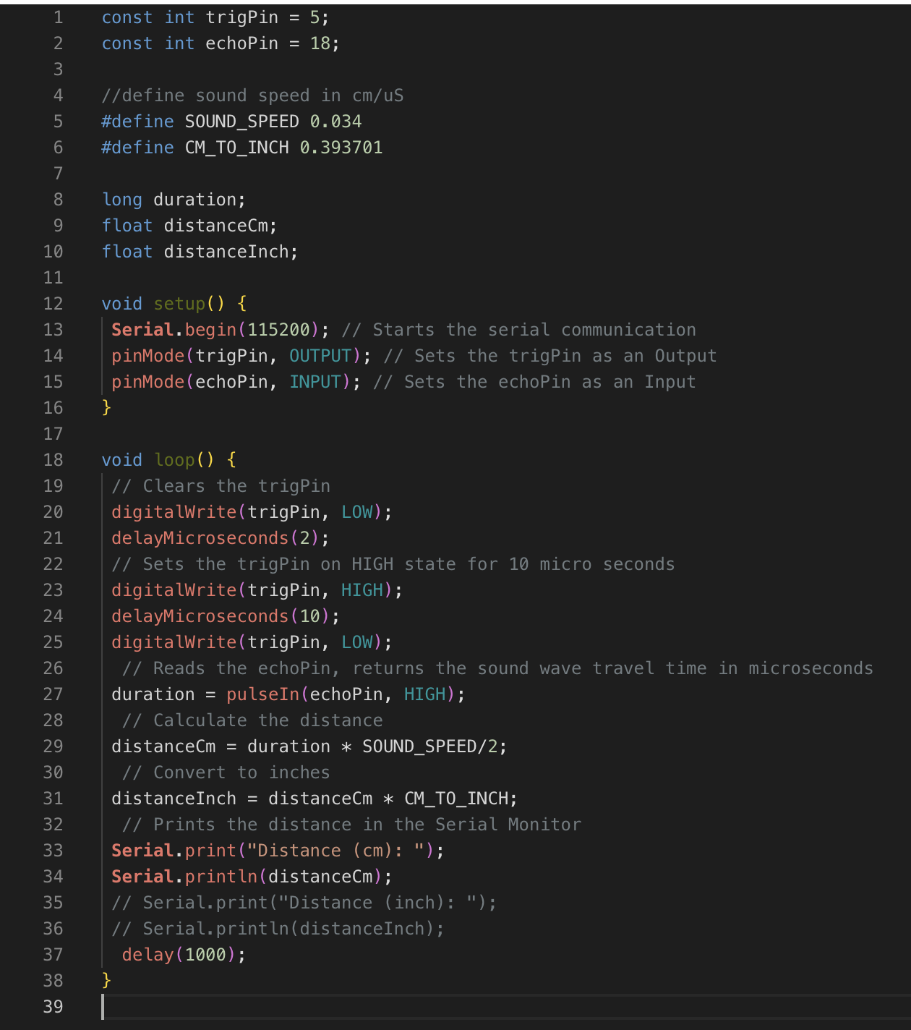

1. Results

